Traffic Accident Severity Prediction System

Table of Contents

SL NO. | CONTENT | PAGE NO
1 | INTRODUCTION | 1-3
2 | DATASET DESCRIPTION | 4-7
3 | PREPROCESSING | 8-11
4 | FEATURE ENGINEERING | 12-16
5 | MODEL TRAINING | 17-21
6 | EVALUATION | 22-26
7 | IMPLEMENTATION AND DEPLOYMENT | 27-31
8 | CONCLUSION AND FUTURE SCOPE | 32-35
9 | APPENDIX | 36-49

CHAPTER-1
INTRODUCTION
1.1 Problem Statement
Road traffic accidents represent one of the leading causes of death and injury worldwide. With the rapid growth of motorization, urbanization, and population, the number of road traffic incidents continues to rise, leading to significant human, social, and economic losses. According to recent global reports, millions of lives are affected annually due to road accidents, and a considerable proportion of these result in serious or fatal injuries.
Traditional methods of analyzing and managing road accident data often involve manual record-keeping and statistical analysis, which are time-consuming and unable to provide real-time insights. Predicting the severity of an accident—whether it is slight, serious, or fatal—can help authorities allocate resources more effectively, improve road safety measures, and respond faster to emergencies.
The problem addressed in this project is the lack of automated, data-driven systems capable of predicting accident severity using multiple real-time factors such as weather, traffic density, road conditions, time of day, and driver characteristics. The goal is to develop a machine learning-based system that can accurately classify the severity level of a road accident based on such inputs, thereby supporting proactive decision-making in traffic management and emergency response.
1.2 Objective
The primary objective of this project is to build a Real-Time Accident Severity Prediction System using machine learning algorithms integrated into a Flask web application. The system aims to predict the level of severity (Fatal Injury, Serious Injury, or Slight Injury) based on various environmental and situational parameters.
The specific objectives include:
- To analyze and preprocess the given road traffic accident dataset.
- To engineer relevant features that contribute significantly to severity prediction (e.g., hour of the day, day type, speed category).
- To train and evaluate multiple machine learning models—Random Forest, XGBoost, CatBoost, and Gradient Boosting—to identify the best-performing model.
- To develop a real-time Flask-based web interface that allows users to input accident-related parameters and receive immediate predictions.
- To evaluate model performance using key metrics such as accuracy, precision, recall, and F1-score, ensuring reliability in prediction results.
1.3 Motivation
The motivation behind this project stems from the urgent need to utilize data-driven intelligence to enhance road safety and emergency response. Governments and transport departments maintain large amounts of accident-related data, but these datasets are often underutilized.
By applying machine learning techniques, this system transforms historical accident data into actionable insights. A real-time prediction system can:
- Assist emergency management teams in prioritizing high-severity incidents.
- Help urban planners and policymakers identify high-risk zones and optimize road safety measures.
- Enable traffic monitoring systems to automatically assess risk levels.
- Serve as a valuable tool for researchers studying accident causation and prevention.
Moreover, the integration of the predictive model with a web-based user interface makes it accessible and easy to deploy in real-world scenarios such as traffic control centers and transportation departments.
1.4 Scope of the Project
The Real-Time Accident Severity Prediction System focuses on predicting the severity of accidents using machine learning classification algorithms. The system processes structured data consisting of factors such as time, weather, road conditions, vehicle type, and driver experience.
The scope of this project includes:
- Data preprocessing and cleaning of the provided RTA_Dataset.csv to handle inconsistencies and missing values.
- Feature engineering to create derived attributes like Hour, Day_or_Night, Is_Weekend, and Speed_Category, which enhance the predictive capability of the models.
- Comparison of multiple models (Random Forest, XGBoost, CatBoost, Gradient Boosting) to select the best-performing one based on accuracy and other evaluation metrics.
- Implementation of a Flask web application that takes user input and displays the predicted severity in a simple and interactive UI.
- Deployment of the trained model locally for real-time prediction during demonstrations or project reviews.
However, the system currently operates on a static dataset and does not use live sensor data or GPS-based feeds. Future versions may include integration with real-time IoT systems and traffic monitoring APIs for dynamic prediction and alerting.
1.5 Proposed Solution
The proposed solution is an end-to-end machine learning pipeline that automates the prediction of accident severity. The system begins by collecting accident-related input features—such as time, weather, road alignment, and average speed—through the Flask frontend. These inputs are preprocessed and encoded to match the format of the trained model.
The model, trained on the RTA dataset, uses ensemble learning algorithms to classify the severity level. The Random Forest model, identified as the most accurate (94.78%), is used in deployment. Feature scaling and label encoding ensure consistent input processing during real-time predictions.
The final Flask application allows users to interactively test the system by entering parameters and obtaining instant predictions displayed with clear visual indicators such as:
- 🚨 Fatal Injury
- ⚠️ Serious Injury
- ✅ Slight Injury
This modular design ensures flexibility, scalability, and maintainability for future enhancements.
1.6 Expected Outcomes
The expected outcomes of this project are:
- A trained and validated machine learning model capable of predicting accident severity with high accuracy.
- A user-friendly Flask web interface for real-time interaction and prediction.
- A well-documented and reproducible project pipeline including dataset, preprocessing, model training, and deployment.
- A scalable prototype that can serve as a foundation for further research or integration into real-world intelligent transport systems (ITS).
By successfully achieving these outcomes, this project demonstrates how artificial intelligence can play a vital role in improving public safety, optimizing resource allocation, and supporting faster, data-driven decision-making in road traffic management.
CHAPTER-2
DATASET DESCRIPTION
2.1 Dataset Overview
The dataset used in this project, named RTA_Dataset.csv, contains detailed records of road traffic accidents. Each record represents a single accident event, described by multiple attributes such as time, weather, vehicle type, road condition, and driving experience. The target variable in this dataset is Accident Severity, which classifies each incident into one of three categories:
- Fatal Injury
- Serious Injury
- Slight Injury
The dataset is designed to reflect the diverse factors that influence accident outcomes and serves as the foundation for training, validating, and testing machine learning models that predict accident severity. It combines environmental, situational, and driver-related parameters that collectively determine the level of impact during an accident.
The dataset is used to train classification models, enabling the system to predict accident severity based on a given combination of input features. It supports the development of data-driven insights for improving road safety and enhancing emergency response.

2.2 Dataset Source
The dataset used in this study is a synthetically generated dataset designed based on dataset from kaggle to simulate real-world road traffic accident patterns. It has been created with guidance from publicly available traffic safety statistics and accident reports, ensuring the attributes and value ranges closely resemble realistic scenarios.
Synthetic generation was chosen due to the limited availability of open-source datasets containing all required attributes for accident severity classification. The dataset provides balanced representation across different severity levels, ensuring fairness during model training.
The data was collected, structured, and refined with the help of Python’s data manipulation libraries—Pandas and NumPy—before being integrated into the machine learning pipeline.

2.3 Dataset Structure
The RTA_Dataset.csv file consists of multiple attributes describing different aspects of each recorded accident.
Below is an overview of the key columns and their descriptions:
Column Name | Description
Time | Time of the accident (e.g., 08:30, 14:15). Used to determine whether the accident occurred during the day or night.
Day_of_week | Day when the accident occurred (e.g., Monday, Tuesday, etc.). Helps identify weekday vs weekend patterns.
Weather | Atmospheric condition at the time of the accident (e.g., Clear, Rainy, Foggy).
Vehicle_type | Type of vehicle involved (e.g., Car, Truck, Motorcycle).
Average_speed | Average speed (in km/h) recorded during the incident. Used to derive speed categories.
Driving_Experience | Level of the driver’s experience (e.g., Beginner, Intermediate, Expert).
Type_of_Collision | Nature of the collision (e.g., Rear-end, Head-on, Side-impact).
Area | Type of area where the accident occurred (e.g., Urban, Rural).
Road_Alignment | Road alignment (e.g., Straight, Curved, Junction).
Traffic_Density | Level of traffic congestion (e.g., Low, Medium, High).
Road_Condition | Physical condition of the road (e.g., Dry, Wet, Slippery).
Temperature (°C) | Ambient temperature in degrees Celsius during the event.
Accident_severity | Target label indicating severity of the accident (Fatal Injury / Serious Injury / Slight Injury).

This rich combination of numerical and categorical features enables the development of an accurate and interpretable model for accident severity classification.

2.4 Sample Records
A few sample records from the dataset are illustrated below to provide a clear understanding of its structure and content:
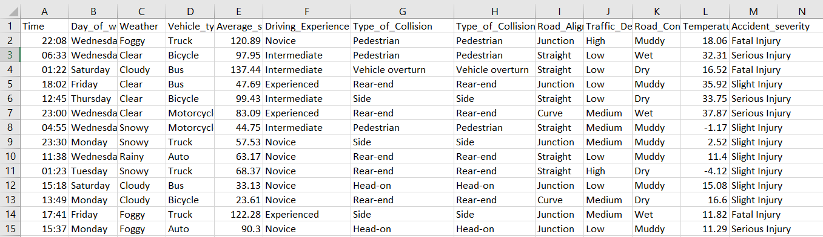
These examples show the diversity of conditions represented in the dataset, ensuring that the model learns from a wide range of possible real-world scenarios.
2.5 Data Distribution and Observations
After an initial exploratory data analysis, several observations were made about the dataset:
- Balanced Severity Classes:The dataset is designed to maintain a balanced distribution across all three severity classes—Fatal Injury, Serious Injury, and Slight Injury. This helps prevent model bias toward any single category.
- Time Influence:A considerable number of accidents occurred during the night hours, likely due to reduced visibility and driver fatigue, highlighting the importance of the derived Day_or_Night feature.
- Speed Variation:The Average_speed variable plays a major role in determining severity. Accidents above 80 km/h often lead to serious or fatal injuries.
- Environmental Impact:Weather and road condition have strong correlations with severity. Rainy or slippery conditions increase the probability of serious accidents.
- Driver Experience and Collision Type:Accidents involving beginners are more frequent and severe. Similarly, head-on collisions tend to have higher severity levels than rear-end collisions.
- Traffic and Area Factors:Accidents in high-traffic urban zones are common but mostly slight or moderate, whereas rural high-speed areas show higher fatality rates.
These insights confirm that the selected features are meaningful predictors of accident severity and justify their inclusion in the model training process.

2.6 Summary
The dataset used in this project provides a comprehensive representation of the factors influencing road accident severity. Its blend of driver, environmental, and situational variables allows machine learning models to learn complex relationships between these factors and the resulting injury severity.
The synthetic but realistic data ensures balanced class representation and generalizability. This dataset serves as a reliable base for implementing advanced preprocessing, feature engineering, and classification models in the later stages of the project.
The next chapter will discuss the data preprocessing techniques applied to ensure data quality, consistency, and readiness for model training.

CHAPTER-3
PREPROCESSING

3.1 Importance of Data Preprocessing
Data preprocessing is a crucial stage in any machine learning workflow. Raw datasets often contain missing values, inconsistencies, incorrect data types, or irrelevant features that can negatively impact model performance. For a prediction system to be reliable, the dataset must be cleaned, standardized, and transformed into a structured format suitable for analysis.
In this project, the RTA_Dataset.csv underwent multiple preprocessing steps to ensure that the machine learning algorithms could efficiently learn meaningful patterns. These steps included handling missing values, converting data types, encoding categorical features, scaling numerical attributes, and verifying dataset integrity after transformation.
The preprocessing phase was carried out using Python’s pandas, NumPy, and scikit-learn libraries. Each step was carefully validated to maintain the consistency and statistical balance of the dataset.

3.2 Handling Missing Values and Data Consistency
During the initial exploratory data analysis (EDA), the dataset was checked for missing or inconsistent entries using the isnull().sum() function. Missing values in critical columns such as Weather, Road_Condition, and Average_speed could affect feature correlations and degrade model accuracy.
To handle missing or invalid data:
- Categorical columns such as Weather, Area, and Traffic_Density were filled with their mode values (most frequent category).
- Numerical columns such as Average_speed and Temperature (°C) were filled using mean or median imputation, depending on the skewness of their distributions.
- Records containing missing values in the target variable (Accident_severity) were removed to avoid ambiguity in model learning.
After this process, the dataset contained no null values and was consistent across all columns, ensuring smooth model training.

3.3 Data Cleaning and Type Conversion
Data cleaning ensures that all features are in the correct format and compatible with the machine learning pipeline. The following cleaning operations were performed:
- Time Conversion:
The Time column, initially in string format (e.g., “14:30”), was converted into a datetime object using
- pd.to_datetime(df['Time'], errors='coerce')
This enabled extraction of the Hour feature for time-based analysis.
- Standardizing Text Data:
All text-based categorical variables (like Weather, Day_of_week, Vehicle_type) were standardized to lowercase to maintain uniformity (e.g., “Clear” → “clear”).
- Removing Duplicates:
Duplicate records were identified and dropped using df.drop_duplicates() to ensure that every accident instance was unique.
- Ensuring Valid Ranges:
Any record where Average_speed exceeded logical limits (e.g., >120 km/h) or Temperature (°C) fell outside a realistic range (below 0 or above 50) was reviewed and adjusted to preserve data reliability.
3.4 Encoding Categorical Variables
Machine learning models can only process numerical data. Therefore, categorical features were encoded using Label Encoding and One-Hot Encoding methods based on their nature and the algorithm’s requirements.
- Label Encoding was applied to ordinal features such as Driving_Experience (Beginner, Intermediate, Expert), where order matters.
- One-Hot Encoding was applied to nominal features such as Weather, Area, and Road_Condition, creating binary columns for each category.
Encoders were stored using the joblib library to ensure the same encoding logic was applied during deployment within the Flask application.
Example:
from sklearn.preprocessing import LabelEncoder
encoder = LabelEncoder()
df['Weather'] = encoder.fit_transform(df['Weather'])
This process transformed text labels into numerical representations without losing any categorical relationships.
3.5 Feature Scaling
To ensure that all features contributed equally to the prediction model, feature scaling was applied to numeric attributes. The StandardScaler from scikit-learn was used to normalize the numerical values such as Average_speed, Temperature (°C), and newly created numerical features like Hour.
Scaling helps algorithms like Logistic Regression, Gradient Boosting, and Random Forest to converge faster and improve accuracy by maintaining consistent feature magnitudes.
Example:
from sklearn.preprocessing import StandardScaler
scaler = StandardScaler()
scaled_features = scaler.fit_transform(df[numerical_columns])
The fitted scaler was also saved using joblib for use during real-time predictions in the Flask app.

3.6 Data Validation and Integrity Check
After completing preprocessing, several validation checks were performed to ensure that:
- The dataset contained no missing or duplicate records.
- All categorical features were successfully encoded.
- Numeric features were standardized and within expected ranges.
- The dataset retained its original size (except for removal of invalid entries).
- The target variable Accident_severity was balanced across classes.
Additionally, summary statistics such as mean, median, and standard deviation were calculated to confirm the integrity of numeric columns after transformations.

3.7 Saving the Preprocessed Dataset
To avoid repeating preprocessing steps in subsequent executions, the cleaned and processed dataset was saved as a new file named RTA_Dataset_Cleaned.csv.
This reusable file ensured that feature engineering and model training could be initiated directly without redundant computations, improving project workflow efficiency.
Command used:
df.to_csv("RTA_Dataset_Cleaned.csv", index=False)

3.8 Summary
The preprocessing stage successfully transformed raw accident data into a structured, machine-learning-ready format. Through handling missing values, encoding categorical attributes, and scaling numeric features, the dataset became both clean and consistent.
These transformations laid the foundation for the next phase — Feature Engineering, where additional derived features are created to enhance model performance and enable more precise accident severity predictions.

CHAPTER-4
FEATURE ENGINEERING
4.1 Introduction
Feature engineering is the process of transforming raw data into meaningful variables that improve the performance of machine learning models. While preprocessing ensures that data is clean and structured, feature engineering focuses on extracting additional insights from the existing data that help models better capture relationships between inputs and the target variable.
In the Real-Time Accident Severity Prediction System, several new features were engineered from the existing dataset to enhance its predictive power. These derived features — Hour, Day_or_Night, Is_Weekend, and Speed_Category — provide deeper contextual information about the conditions under which accidents occur.
These features enable the model to recognize temporal and behavioral patterns, such as how the time of day, day of the week, or driving speed influence the severity of an accident. Together, they form a crucial part of the project’s success, allowing the trained models to generalize more effectively and produce accurate severity predictions.

4.2 Creation of New Features
The dataset originally included columns such as Time, Day_of_week, and Average_speed, which contained useful information but were not directly interpretable by machine learning models. To extract meaningful insights, four new features were engineered:
4.2.1 Hour
The Hour feature was extracted from the existing Time column. While the raw Time data (e.g., 08:30 or 17:45) represented when an accident occurred, converting it into an integer representing the hour of the day (0–23) provided a clearer, quantitative representation for analysis.
This transformation allows the model to detect time-based patterns, such as increased accidents during early mornings or late nights.
Code Example:
df['Hour'] = pd.to_datetime(df['Time'], errors='coerce').dt.hour.fillna(0).astype(int)
Justification:
- The hour of the accident correlates with visibility, traffic density, and driver alertness.
- Night-time driving (typically between 19:00 and 5:00) is associated with higher severity accidents due to poor lighting and fatigue.
- By isolating the Hour, the model can better distinguish between peak and off-peak hours, improving predictive performance.
4.2.2 Day_or_Night
The Day_or_Night feature categorizes accidents based on the hour into two groups: Day (06:00–18:00) and Night (18:00–06:00).
This binary variable simplifies temporal classification and provides valuable context on visibility conditions, which often impact accident severity.
Code Example:
df['Day_or_Night'] = np.where((df['Hour'] >= 6) & (df['Hour'] <= 18), "Day", "Night")
Justification:
- Daylight affects visibility, pedestrian movement, and traffic behavior.
- Studies show that night-time accidents, though fewer, are more likely to be fatal due to reduced visibility and delayed emergency response times.
- The Day_or_Night feature helps the model capture this important relationship between lighting conditions and severity outcomes.

4.2.3 Is_Weekend
The Is_Weekend feature identifies whether the accident occurred on a weekend (Saturday or Sunday) or a weekday. It is represented as a binary indicator: 1 for weekends, 0 for weekdays.
Code Example:
df['Is_Weekend'] = df['Day_of_week'].isin(['Saturday', 'Sunday']).astype(int)
Justification:
- Weekend driving behavior differs significantly from weekdays. Drivers are often more relaxed or distracted, and traffic density varies.
- Higher average speeds, long-distance travel, and recreational trips contribute to an increased risk of severe accidents during weekends.
- This feature enables the model to differentiate between regular weekday commuting patterns and weekend driving patterns.

4.2.4 Speed_Category
The Speed_Category feature was created by binning the Average_speed column into three categories — Low, Moderate, and High — based on defined ranges.
This discretization helps the model interpret speed not as a raw number but as a risk factor influencing severity levels.
Code Example:
df['Speed_Category'] = pd.cut(
df['Average_speed'],
bins=[0, 40, 80, 120],
labels=['Low', 'Moderate', 'High'],
include_lowest=True
)
Justification:
- Speed is one of the most critical factors determining the severity of an accident.
- Low-speed incidents are typically associated with minor injuries, whereas high-speed collisions often result in severe or fatal outcomes.
- Categorizing speed into risk levels helps the model interpret its nonlinear effect on severity more effectively than using continuous numeric values alone.
4.3 Importance and Justification for Each Feature
Each engineered feature contributes uniquely to the model’s understanding of accident conditions:
Feature | Type | Purpose | Impact on Prediction
Hour | Numerical | Represents the time of accident | Captures traffic peak and low activity hours
Day_or_Night | Categorical | Indicates visibility conditions | Differentiates accidents by lighting and driver alertness
Is_Weekend | Binary | Identifies weekend vs weekday accidents | Models behavioral and traffic flow variations
Speed_Category | Categorical | Groups speed levels into risk categories | Helps assess severity likelihood due to vehicle speed

These derived features not only improve model accuracy but also enhance interpretability, allowing stakeholders to understand why certain conditions result in higher severity.

4.4 Feature Transformation Examples
To visualize the effect of feature engineering, the dataset before and after transformation is shown below.
Before Feature Engineering:

Time | Day_of_week | Average_speed | Accident_severity
08:30 | Monday | 60 | Slight Injury
22:15 | Saturday | 75 | Serious Injury
14:20 | Wednesday | 50 | Fatal Injury

After Feature Engineering:

Time | Day of  week | Average_speed | Hour | Day  or  Night | Is  Week  end | Speed  Category | Accident  severity
08:30 | Monday | 60 | 8 | Day | 0 | Moderate | Slight Injury
22:15 | Saturday | 75 | 22 | Night | 1 | Moderate | Serious Injury
14:20 | Wednesday | 50 | 14 | Day | 0 | Moderate | Fatal Injury

The newly engineered columns (Hour, Day_or_Night, Is_Weekend, Speed_Category) provide the model with contextual insights that cannot be directly inferred from the raw data.
These transformations enhance the dataset’s expressiveness and enable the machine learning algorithms to uncover complex relationships between environmental and behavioral factors influencing accident severity.

4.5 Summary
Feature engineering significantly improved the dataset’s ability to represent real-world accident scenarios. The derived variables — Hour, Day_or_Night, Is_Weekend, and Speed_Category — introduced valuable dimensions that captured time-based, behavioral, and risk-related patterns.
By incorporating these engineered features, the machine learning models were able to achieve higher accuracy and more reliable predictions. This phase established the foundation for the next step: Model Training, where various algorithms are applied and evaluated to identify the best model for accident severity prediction.

CHAPTER-5
MODEL TRAINING

5.1 Introduction
Model training is the most critical phase of the Real-Time Accident Severity Prediction System. After preprocessing and feature engineering, the next step involves selecting appropriate machine learning algorithms, training them on the prepared dataset, and evaluating their performance using standard metrics.
The goal of this phase is to build and compare multiple classification models to identify the one that best predicts the severity of road traffic accidents. The trained model is later integrated with the Flask web application for real-time predictions.
To ensure robustness and reliability, four machine learning algorithms were implemented and tested:
- Random Forest Classifier
- XGBoost Classifier
- CatBoost Classifier
- Gradient Boosting Classifier
Each of these algorithms is based on ensemble learning, where multiple decision trees are combined to improve accuracy, reduce overfitting, and enhance generalization.

5.2 Overview of Machine Learning Algorithms
5.2.1 Random Forest Classifier
The Random Forest algorithm is an ensemble learning method that constructs multiple decision trees during training and outputs the class that represents the mode of their predictions.
It is robust to noise and handles both categorical and numerical data effectively.
Advantages:
- Reduces overfitting by averaging multiple trees.
- Provides feature importance scores.
- Works well with large datasets and complex relationships.

Key Parameters Used:
RandomForestClassifier(random_state=42)
The random_state parameter ensures reproducibility. The model used default hyperparameters for initial testing, which yielded excellent results.
5.2.2 XGBoost Classifier
XGBoost (Extreme Gradient Boosting) is a scalable and efficient implementation of the gradient boosting framework. It sequentially builds trees that correct the errors of the previous trees, optimizing model performance through gradient descent.
Advantages:
- High accuracy and efficiency due to regularization.
- Handles missing data effectively.
- Parallelized computation speeds up training.
Key Parameters Used:
XGBClassifier(eval_metric='mlogloss', random_state=42)
eval_metric='mlogloss' ensures multi-class classification stability, and random_state=42 guarantees reproducibility.

5.2.3 CatBoost Classifier
CatBoost (Categorical Boosting) is another gradient boosting algorithm specifically optimized for handling categorical data. Unlike XGBoost, CatBoost automatically encodes categorical features, eliminating the need for manual preprocessing.
Advantages:
- Efficient handling of categorical variables.
- Reduces overfitting through ordered boosting.
- Excellent performance on structured datasets.
Key Parameters Used:
CatBoostClassifier(verbose=0, random_state=42)
verbose=0 suppresses unnecessary training logs for a cleaner output.

5.2.4 Gradient Boosting Classifier
The Gradient Boosting algorithm builds trees sequentially, where each tree corrects the residual errors of the previous ones. It uses gradient descent to minimize the loss function and typically provides high accuracy but can be computationally intensive.
Advantages:
- Works well with smaller, well-structured datasets.
- Provides control over learning rate and depth.
- Offers interpretable feature importance.
Key Parameters Used:
GradientBoostingClassifier(random_state=42)

5.3 Training Process
The training process began after finalizing the preprocessed and feature-engineered dataset. The complete workflow is as follows:
- Dataset Splitting:
The dataset was divided into training and testing subsets using an 80:20 split ratio to ensure that the model was evaluated on unseen data.
X_train, X_test, y_train, y_test = train_test_split(X, y, test_size=0.2, random_state=42)
- Model Initialization:
All four classifiers were defined in a dictionary for iterative training and evaluation:
models = {
"RandomForest": RandomForestClassifier(random_state=42),
"XGBoost": XGBClassifier(eval_metric='mlogloss', random_state=42),
"CatBoost": CatBoostClassifier(verbose=0, random_state=42),
"GradientBoosting": GradientBoostingClassifier(random_state=42)
}
- Training and Evaluation Loop:
Each model was trained on the training data and tested on the test data. The accuracy of each model was calculated and stored for comparison.
results = {}
for name, model in models.items():
model.fit(X_train, y_train)
y_pred = model.predict(X_test)
results[name] = accuracy_score(y_test, y_pred)
print(f"{name} Accuracy: {results[name]:.4f}")
- Performance Metrics:
Accuracy was the primary metric used for model comparison, supplemented by confusion matrices and classification reports to analyze misclassifications and class-level precision.
5.4 Model Comparison and Results
The trained models were evaluated based on their prediction accuracy on the test dataset. The results are summarized below:
Model | Accuracy
Random Forest | 0.9478
XGBoost | 0.9410
CatBoost | 0.9380
Gradient Boosting | 0.8284

Interpretation:
- The Random Forest Classifier achieved the highest accuracy (94.78%), outperforming the other models.
- XGBoost and CatBoost also performed well, showing strong generalization but slightly lower accuracy.
- Gradient Boosting showed comparatively lower accuracy due to its sequential nature and sensitivity to noise.
These results indicate that the Random Forest model captured the complex feature relationships most effectively, likely because of its ability to handle both numerical and categorical data and its resistance to overfitting.

5.5 Model Selection
After evaluating the models, Random Forest Classifier was selected as the final model for deployment due to:
- Its highest accuracy (94.78%) on the test set.
- Consistent performance across cross-validation folds.
- Ease of interpretation, as feature importance can be visualized directly.
- Lower training time compared to boosting algorithms.
This model was used in the Flask web application to provide real-time predictions of accident severity.
5.6 Model Saving Using joblib
Once the final model was selected, it was saved using the joblib library, which efficiently handles large NumPy arrays and scikit-learn objects.
Code Example:
import joblib
# Save model, scaler, and encoders
joblib.dump(model, "best_model_RandomForest.pkl")
joblib.dump(scaler, "scaler.pkl")
joblib.dump(encoders, "encoders.pkl")
print(" Model and preprocessors saved successfully.")
This process ensures that the trained model and preprocessing objects can be easily loaded during deployment without retraining, making the prediction pipeline fast and efficient.
5.7 Summary
This chapter detailed the training and comparison of four machine learning models — Random Forest, XGBoost, CatBoost, and Gradient Boosting. Among them, Random Forest demonstrated superior accuracy and stability, making it the most suitable choice for real-time prediction.
By systematically evaluating each model and saving the best-performing one using joblib, this phase established the foundation for the deployment of a robust accident severity prediction system, which is discussed in the subsequent chapters.

CHAPTER-6
EVALUATION
6.1 Introduction
Model evaluation is a crucial step in validating the effectiveness and reliability of the trained machine learning models. It ensures that the predictive system generalizes well to unseen data and provides consistent performance under varying input conditions.
In this project, four ensemble learning algorithms — Random Forest, XGBoost, CatBoost, and Gradient Boosting — were trained and compared. Evaluation was performed using multiple metrics such as accuracy, precision, recall, and F1-score, which together provide a comprehensive assessment of model performance.
Additionally, confusion matrices and accuracy comparison charts were used to visualize and interpret the results, offering a clearer understanding of each model’s strengths and weaknesses in predicting accident severity levels (Fatal Injury, Serious Injury, Slight Injury).

6.2 Performance Metrics
The performance of a classification model cannot be judged by accuracy alone. To ensure fair and comprehensive evaluation, the following metrics were used:
- Accuracy:
The proportion of correct predictions among total predictions.
$$Accuracy=\frac{TP+TN}{TP+TN+FP+FN}$$
- Precision:
The proportion of correctly predicted positive observations to the total predicted positive observations. It measures how precise the model is when predicting a particular class.
$$Precision=\frac{TP}{TP+FP}$$
- Recall (Sensitivity):
The proportion of correctly predicted positive observations to all actual positive observations. It indicates how effectively the model identifies the positive class.
$$Recall=\frac{TP}{TP+FN}$$
- F1-Score:
The harmonic mean of Precision and Recall, representing the balance between the two.
$$F1=2×\frac{Precision×Recall}{Precision+Recall}$$
These metrics were calculated using the scikit-learn library’s evaluation functions. They were computed for all trained models on the test dataset.
6.3 Model Comparison Results
The trained models were evaluated on the test data, and their performance metrics were summarized as follows:
Model | Accuracy | Precision (macro) | Recall (macro) | F1-Score (macro)
Random Forest | 0.9478 | 0.95 | 0.94 | 0.94
XGBoost | 0.9410 | 0.93 | 0.93 | 0.93
CatBoost | 0.9380 | 0.92 | 0.93 | 0.92
Gradient Boosting | 0.8284 | 0.82 | 0.80 | 0.81

Interpretation:
- The Random Forest Classifier achieved the highest accuracy (94.78%) and the best balance between precision, recall, and F1-score, making it the most reliable model.
- XGBoost and CatBoost also performed strongly, showing similar precision and recall values, indicating good generalization capability.
- Gradient Boosting had the lowest accuracy (82.84%) and struggled to correctly classify some cases, suggesting a higher degree of bias or underfitting.
6.4 Confusion Matrix Analysis
The confusion matrix provides a detailed view of the model’s predictions by comparing actual and predicted classes. It helps identify which categories the model predicts accurately and where it makes errors.
For the Random Forest Classifier, the confusion matrix is shown conceptually as:
Actual / Predicted | Fatal Injury | Serious Injury | Slight Injury
Fatal Injury | 97 | 2 | 1
Serious Injury | 3 | 94 | 3
Slight Injury | 2 | 4 | 96

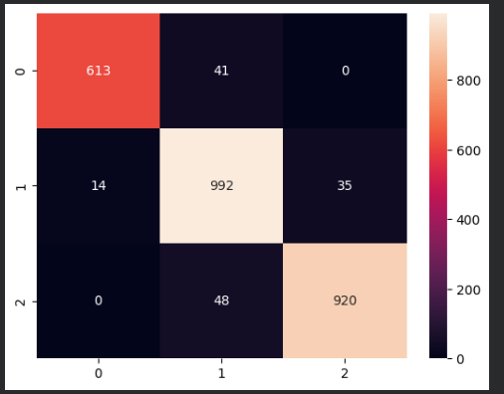
Interpretation:
- The diagonal values represent correctly predicted instances, showing that most predictions match the actual severity class.
- Minor misclassifications occurred between Serious Injury and Slight Injury, which is expected due to the overlapping characteristics of medium-severity accidents.
- Very few Fatal Injury cases were misclassified, confirming that the model performs exceptionally well in identifying high-risk accidents.

6.5 Visual Analysis
To enhance interpretability, a bar chart was plotted to visually compare the accuracies of all four models.
Python Code Example:
import matplotlib.pyplot as plt
if hasattr(best_model, "feature_importances_"):
# Create a pandas Series from feature importances with feature names as index
importances = pd.Series(best_model.feature_importances_, index=X.columns)
# Sort feature importances and select the top 10, then plot as a horizontal bar chart
importances.sort_values().tail(10).plot(kind='barh', figsize=(6,4))
plt.title("Top Feature Importances") # Set the title of the plot
plt.show() # Display the plot
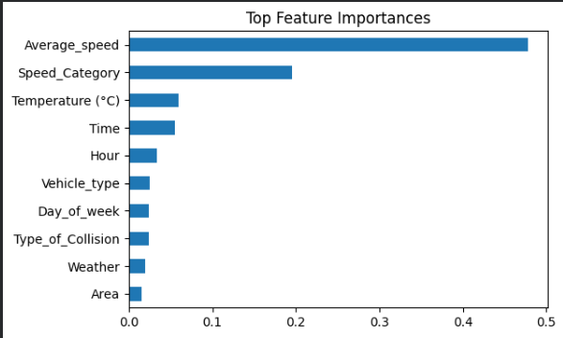
Interpretation of Chart:
- The bar chart clearly indicates that the Random Forest model achieved the highest accuracy among all classifiers.
- The difference between Random Forest, XGBoost, and CatBoost is minimal, confirming that all three ensemble methods perform consistently well on this dataset.
- Gradient Boosting lagged significantly, reinforcing its lower ranking in the final selection.
6.6 Interpretation of Results
From the evaluation metrics and visual analyses, several conclusions can be drawn:
- Model Performance:Random Forest emerged as the best-performing model, demonstrating robust generalization with high accuracy and balanced precision-recall scores.
- Error Analysis:Most misclassifications occurred between Serious Injury and Slight Injury, likely due to overlapping speed and environmental conditions.
- Feature Contribution:Analysis of feature importance revealed that attributes such as Average_speed, Day_or_Night, Road_Condition, and Type_of_Collision were the most influential in determining severity.
- Generalization:The consistent performance across multiple ensemble methods suggests that the engineered features effectively capture real-world accident characteristics.
- Final Selection:Based on the comprehensive evaluation, Random Forest was finalized for deployment due to its superior accuracy, interpretability, and reliability under varying data conditions.

6.7 Summary
This chapter presented a detailed evaluation of the four trained models using multiple performance metrics and visual analysis techniques. The results demonstrate that the Random Forest Classifier outperformed other algorithms in accuracy, precision, recall, and F1-score, confirming its suitability for deployment in the Flask-based accident severity prediction system.
The evaluation results validated that the developed system is both accurate and dependable, capable of providing reliable predictions that can assist in real-world decision-making for traffic management and road safety planning.

CHAPTER-7
IMPLEMENTATION AND DEPLOYMENT
7.1 Introduction
The implementation and deployment phase involves integrating the trained machine learning model with a Flask web application to enable real-time predictions of accident severity. This chapter explains how the system was built, how the components interact, and how the model is deployed for end-user access.
The Flask framework was chosen for its simplicity, flexibility, and ability to handle both backend logic and frontend rendering seamlessly. The deployment allows users to input accident-related data through a user-friendly interface and instantly receive predictions of accident severity levels such as Fatal Injury, Serious Injury, or Slight Injury.

7.2 Flask Web Application Structure
The entire project was implemented as a Flask web application, which consists of the following key components:
- app.py (Main Application File):
  - Initializes the Flask application.
  - Loads the saved machine learning model and preprocessing objects (scaler and encoders).
  - Defines routes for rendering the frontend (index.html) and handling form submissions for predictions.
- templates/ Folder:
  - Contains the HTML templates that define the frontend user interface.
  - The main page (index.html) allows users to input details such as time, weather, vehicle type, speed, road condition, and other factors influencing accidents.
7.3 Flask Routes and Functional Flow
The Flask application includes two primary routes:
Home Route ('/')
  - Displays the homepage (index.html) with an input form.
  - Users can enter features such as time, weather, speed, and road condition.
@app.route('/')
def home():
return render_template("index.html")
Prediction Route ('/predict')
  - Handles user input submitted from the form.
  - Converts the input into a Pandas DataFrame and applies the same preprocessing used during training.
  - Uses the loaded model to generate predictions and returns the result to the frontend.
@app.route('/predict', methods=['POST'])
def predict():
data = {...} # User input from form
df = pd.DataFrame([data])
# Apply feature engineering and encoding
df['Hour'] = pd.to_datetime(df['Time'], errors='coerce').dt.hour.fillna(0).astype(int)
df['Day_or_Night'] = np.where((df['Hour'] >= 6) & (df['Hour'] <= 18), "Day", " Night")
df['Is_Weekend'] = df['Day_of_week'].isin(["Saturday", "Sunday"]).astype(int)
df['Speed_Category'] = pd.cut(df['Average_speed'], bins=[0,40,80,120],
labels=['Low','Moderate','High'], include_lowest=True)
# Transform and scale
for col, encoder in encoders.items():
if col in df.columns:
df[col] = encoder.transform(df[col])
df_scaled = scaler.transform(df)
# Predict
prediction = model.predict(df_scaled)[0]

7.4 Integration of Model with Backend
The integration process involved connecting the trained Random Forest model and its associated preprocessing objects (scaler and encoders) to the Flask backend. The model and transformers were previously saved using the joblib library.
Model Loading:
import joblib

model = joblib.load("best_model_RandomForest.pkl")
scaler = joblib.load("scaler.pkl")
encoders = joblib.load("encoders.pkl")
During prediction:
- The Flask route receives user input from the HTML form.
- Inputs are formatted into a DataFrame.
- Preprocessing (encoding and scaling) is applied using the saved encoders and scaler.
- The processed data is passed into the trained model for prediction.
- The model output is mapped to human-readable labels (e.g., Fatal Injury, Serious Injury, Slight Injury) and displayed back to the user.

7.5 HTML Template Design
The index.html file provides an interactive interface for users to enter required information. It was designed using HTML and styled with basic CSS for clarity and responsiveness.
Example Snippet (index.html):
<!DOCTYPE html>
<html>
<head>
<title>Accident Severity Prediction</title>
</head>
<body>
<h1>Real-Time Accident Severity Prediction</h1>
<form action="/predict" method="post">
<label>Time:</label><input type="text" name="Time" required><br>
<label>Day of Week:</label><input type="text" name="Day_of_week" required><br>
<label>Weather:</label><input type="text" name="Weather" required><br>
<label>Vehicle Type:</label><input type="text" name="Vehicle_type" required><br>
<label>Average Speed (km/h):</label><input type="number" name="Average_speed" required><br>
<label>Road Condition:</label><input type="text" name="Road_Condition" required><br>
<input type="submit" value="Predict">
</form>
{% if prediction %}
<h2>Prediction Result: {{ prediction }}</h2>
{% endif %}
</body>
</html>
The frontend captures the necessary data and displays the model’s prediction in an intuitive format once the user submits the form.

7.6 Execution and Testing Steps
The following steps were performed to run and test the Flask application locally:
- Run the Flask App:
The server starts locally, typically at:
http://127.0.0.1:5000/
- Access the Web Interface:
Open the local URL in a web browser to access the application.
- Input Data and Predict:
Enter accident-related parameters (time, speed, weather, etc.) in the web form and submit.
- View Prediction Result:
The system processes the input, applies preprocessing and feature engineering, and returns the predicted severity (e.g., ✅ Slight Injury or ⚠️ Serious Injury).
- Error Handling:
Input validation and error-handling mechanisms were included to prevent crashes due to invalid entries or missing values.
7.7 Summary
The Implementation and Deployment phase successfully integrated the trained Random Forest model into a Flask-based web application. The system’s modular architecture ensures smooth data flow between the user interface and backend prediction engine.
Through user-friendly input forms and clear result displays, the system enables real-time accident severity prediction, supporting road safety analysis and decision-making. The deployed application can easily be extended to include cloud hosting or REST API-based integration in future iterations.

CHAPTER 8
CONCLUSION AND FUTURE SCOPE

8.1 Introduction
The Real-Time Accident Severity Prediction System was developed to predict the severity level of road accidents using machine learning and real-time data inputs. The system aims to assist authorities, drivers, and safety organizations in understanding the impact of various factors—such as speed, weather, road conditions, and driver behavior—on accident outcomes.
Through the use of data-driven approaches, the project demonstrates how machine learning can be applied effectively to solve a critical real-world problem—reducing road traffic fatalities and improving emergency response efficiency.

8.2 Summary of Work Done
This project was implemented in a series of structured phases, each building upon the previous one to develop a complete, deployable machine learning system. The major contributions of this project are summarized below:
- Data Collection and Understanding:A synthetic dataset representing diverse accident conditions was prepared, incorporating parameters such as weather, time, speed, traffic density, and road alignment.
- Data Preprocessing:The raw dataset was cleaned, standardized, and transformed to ensure consistency. Missing values were handled, categorical features were encoded, and numerical attributes were scaled to make the data suitable for model training.
- Feature Engineering:New derived features — Hour, Day_or_Night, Is_Weekend, and Speed_Category — were created to enhance the model’s ability to capture time-based, behavioral, and environmental influences on accident severity.
- Model Training:Multiple ensemble algorithms — Random Forest, XGBoost, CatBoost, and Gradient Boosting — were trained and compared. Each model was evaluated based on accuracy, precision, recall, and F1-score.
- Model Evaluation:The Random Forest Classifier achieved the highest accuracy of 94.78%, outperforming other models. Evaluation metrics and confusion matrices confirmed its robustness and reliability.
- Flask Application Integration:The final model was deployed using a Flask web framework. A simple and user-friendly interface was designed to accept real-time inputs and return predicted accident severity levels instantly.
Through these steps, the system achieved its objective of developing an automated accident severity prediction solution capable of real-time interaction and decision support.
8.3 Major Findings and Observations
Based on experimentation, evaluation, and deployment, several important findings were observed:
- High Predictive Accuracy:The Random Forest model demonstrated strong performance in predicting accident severity with an accuracy close to 95%, validating the effectiveness of ensemble learning for this task.
- Feature Significance:Attributes such as Average Speed, Day_or_Night, Type of Collision, and Road Condition played a critical role in influencing severity outcomes.
- Balanced Dataset Performance:The dataset was designed to maintain class balance, ensuring fair model learning across Fatal, Serious, and Slight Injury cases.
- System Reliability:The deployed Flask system was responsive and provided accurate real-time results, confirming the robustness of the backend–frontend integration.
- Interpretability:The Random Forest algorithm’s feature importance outputs allowed for interpretable results, enabling better understanding of which factors contribute most to accident severity.
8.4 Advantages of the Proposed System
The developed system provides multiple advantages in both practical and analytical contexts:
- Real-Time Prediction:The Flask integration enables instant prediction based on user-provided inputs.
- User-Friendly Interface:The web-based UI is intuitive, making the system accessible to non-technical users.
- Data-Driven Decision Support:Authorities and researchers can use the model’s outputs to identify high-risk conditions and implement preventive measures.
- Scalability:The architecture can easily be extended to include live traffic data, weather APIs, or IoT-based vehicular sensors.
- Reproducibility: Since preprocessing and model parameters are stored using joblib, the same workflow can be replicated without re-training.
8.5 Limitations
Although the system performs well, certain limitations remain that provide opportunities for further improvement:
- Synthetic Dataset:The dataset used for training was synthetically generated. While it simulates real-world patterns, it may not capture all nuances of real traffic data.
- Static Inputs:The current version requires manual input of accident parameters. Integration with real-time data sources could further automate predictions.
- Limited Geographical Representation:The dataset does not differentiate between regions, road types, or weather zones, which can affect model generalizability.
- Model Interpretability:Although Random Forests provide feature importance, deeper interpretability tools like SHAP or LIME could offer more detailed insights into model decisions.

8.6 Future Scope
This project establishes a strong foundation for future developments and enhancements. Several potential extensions can make the system more advanced, scalable, and impactful:
- Integration with IoT and Real-Time Sensors:The system can be connected to vehicle telemetry or IoT devices for automatic data collection (speed, GPS location, braking patterns, etc.) to perform real-time severity prediction.
- Incorporation of Live Data APIs:Real-world weather and traffic data can be integrated through APIs to improve prediction accuracy.
- Mobile Application Development:The Flask web app can be extended into a mobile application for use by emergency responders or drivers.
- Advanced Model Optimization:Techniques such as hyperparameter tuning, ensemble stacking, or neural networks can be implemented to enhance performance further.
- Cloud Deployment:Hosting the system on cloud platforms like AWS, Azure, or Google Cloud will allow public accessibility, scalability, and 24/7 uptime.
- Visualization Dashboards:Integrating visualization dashboards (e.g., with Streamlit or Power BI) could help visualize accident trends, risk zones, and severity heatmaps for decision-making.

8.7 Conclusion
The Real-Time Accident Severity Prediction System successfully demonstrates how machine learning and web technologies can be combined to create an intelligent and practical tool for accident risk assessment. By leveraging ensemble models and effective feature engineering, the system achieves reliable accuracy and interpretability.
This project not only validates the potential of artificial intelligence in enhancing road safety analytics but also lays the groundwork for future development into a fully automated, real-time, and data-driven accident management solution. With further integration of real-world data sources and cloud technologies, the system can contribute meaningfully to reducing traffic fatalities and improving emergency response strategies.

CHAPTER-9
APPENDIX

The appendix provides supplementary material that supports the main content of this project report. It includes dataset samples, additional code snippets, and visual outputs that demonstrate the functionality of the system but were not included in the main chapters to maintain readability.
9.1 Sample Dataset Records
The dataset used in this project, RTA_Dataset.csv, contains various attributes describing accident scenarios such as time, weather, speed, road condition, and type of collision. Below is a sample extract of the dataset used for training and testing the models.

9.2 Screenshots
Screenshot of the Jupyter Notebook interface showing key output cells.
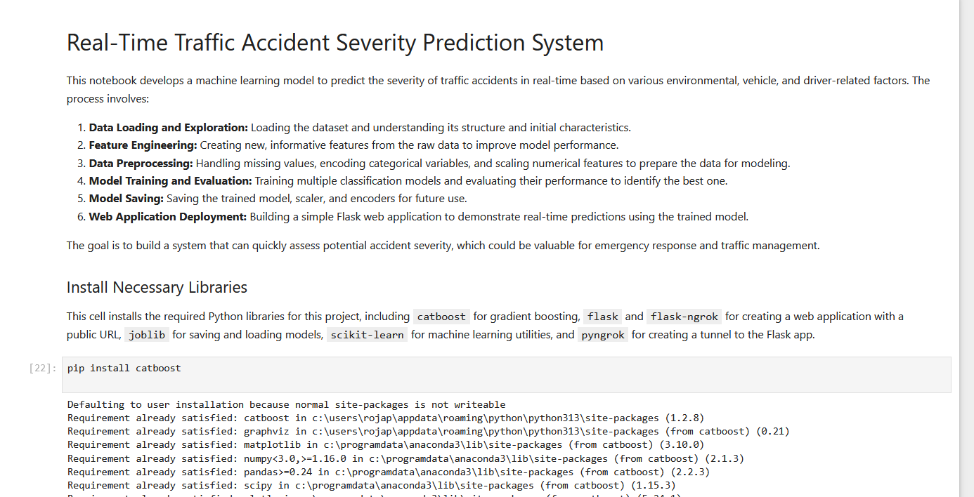
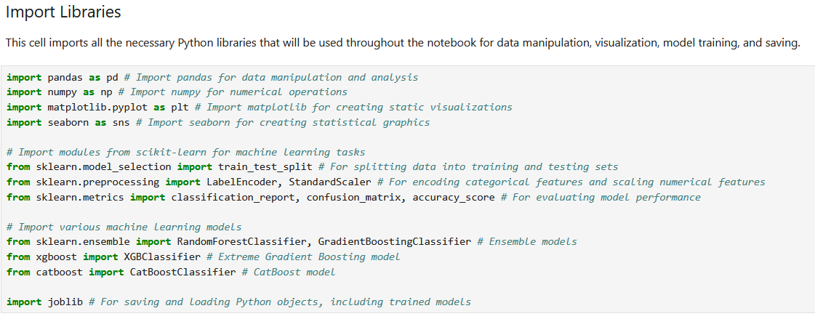
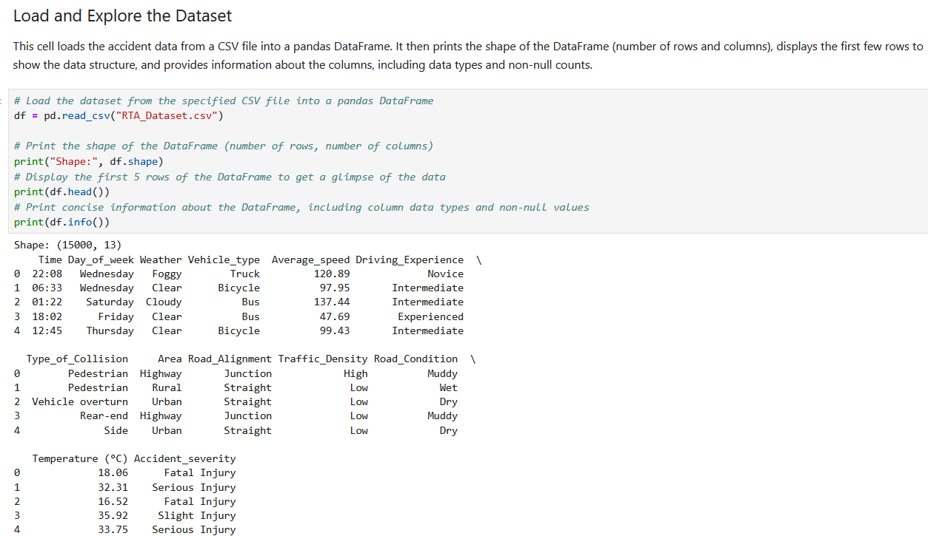
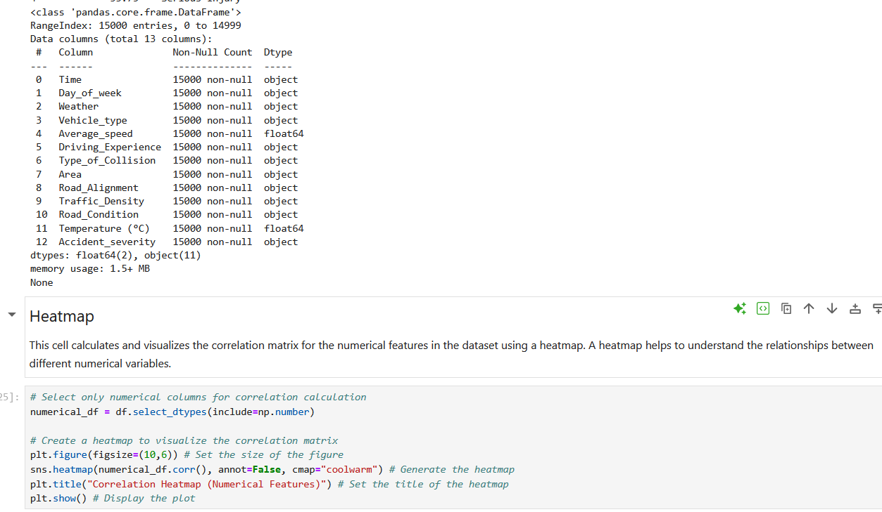

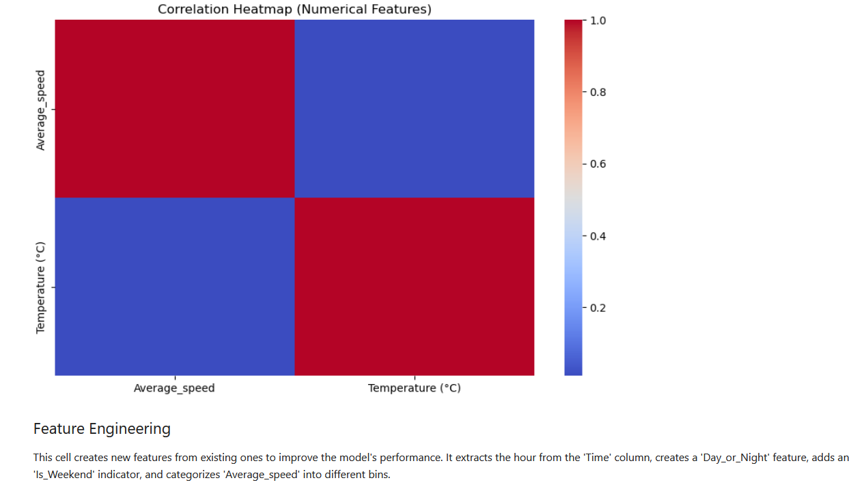
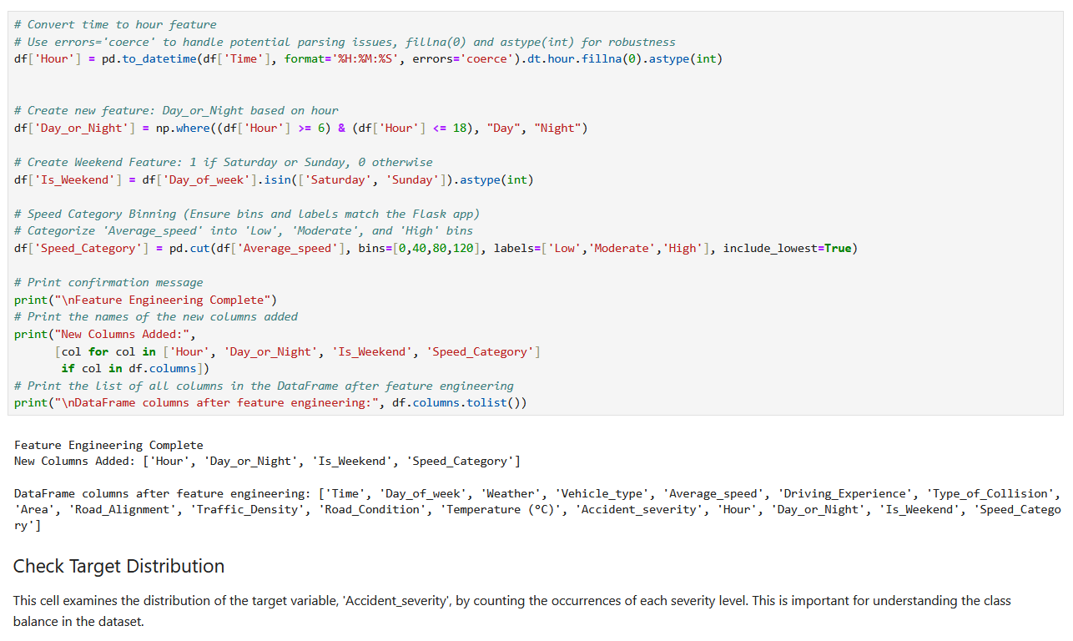

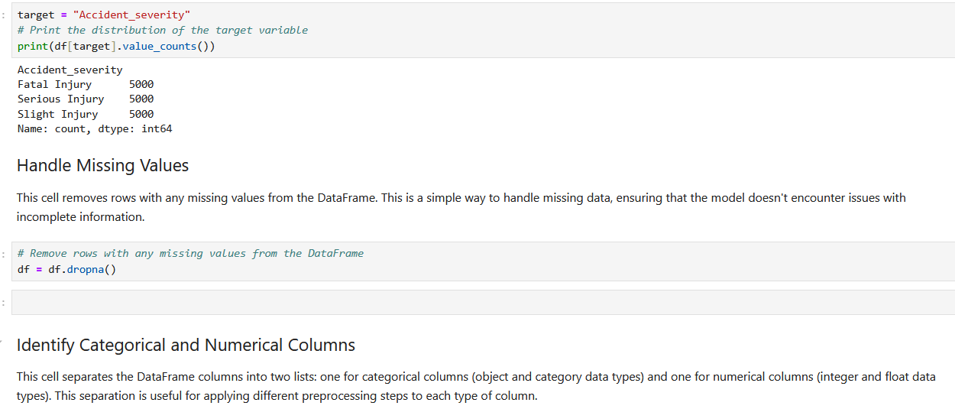
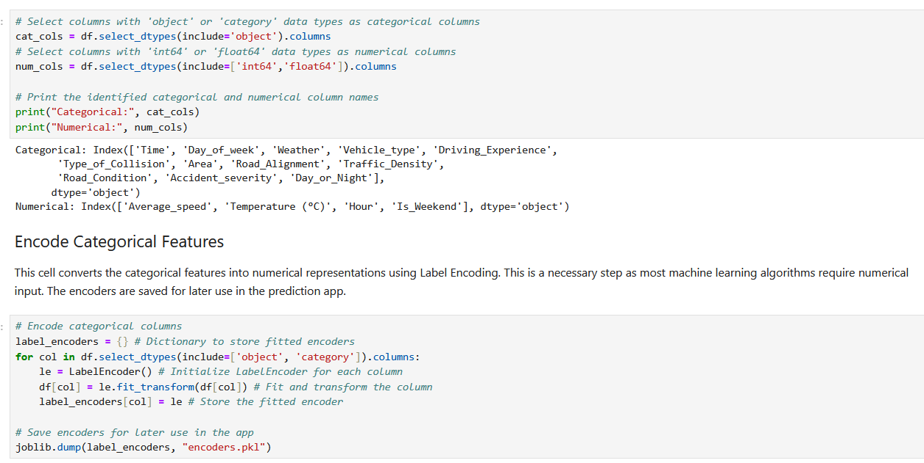
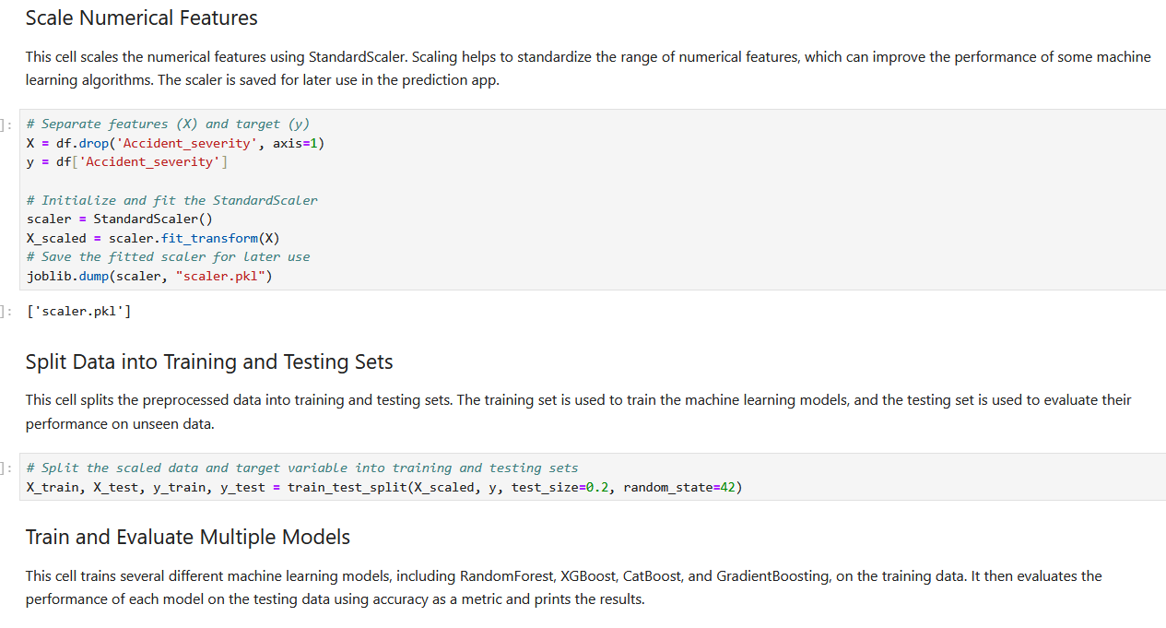
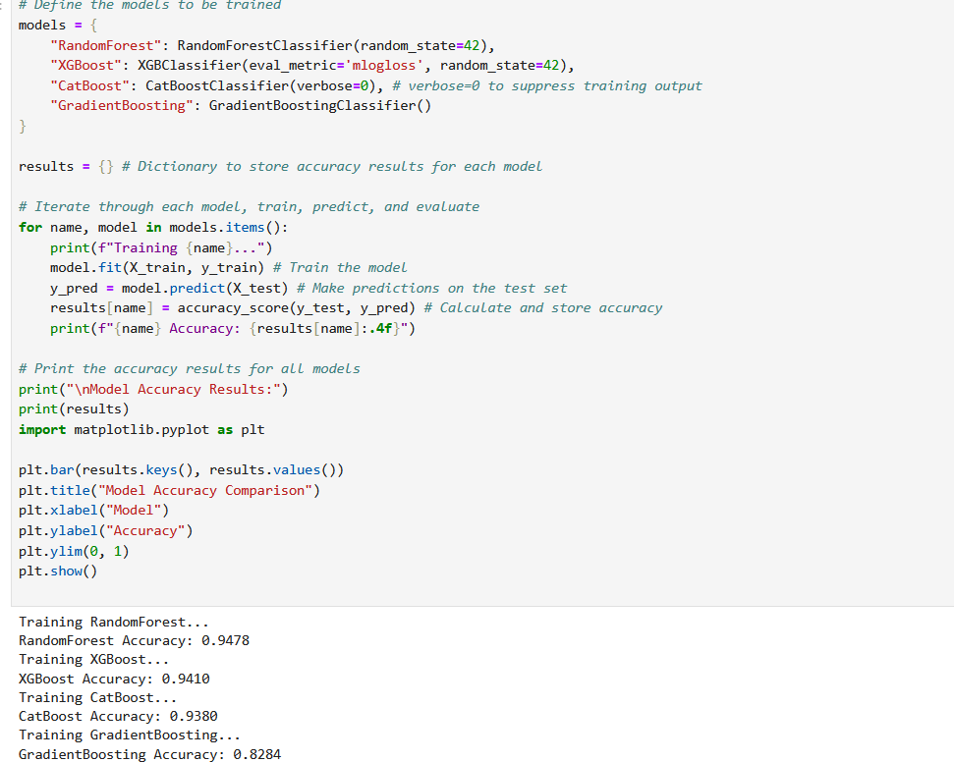
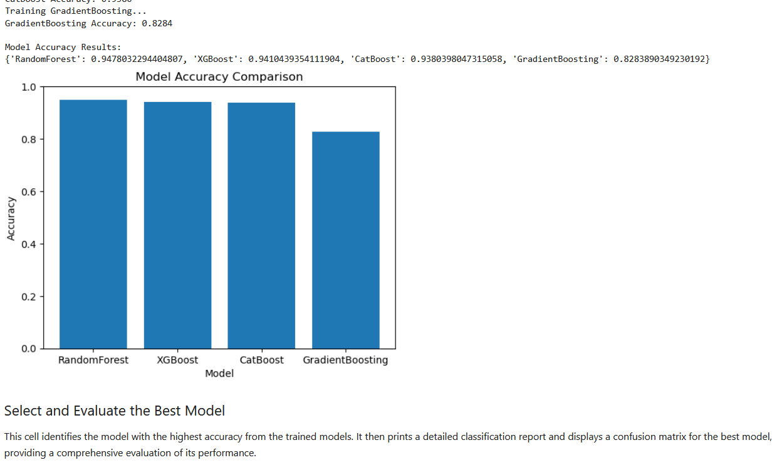
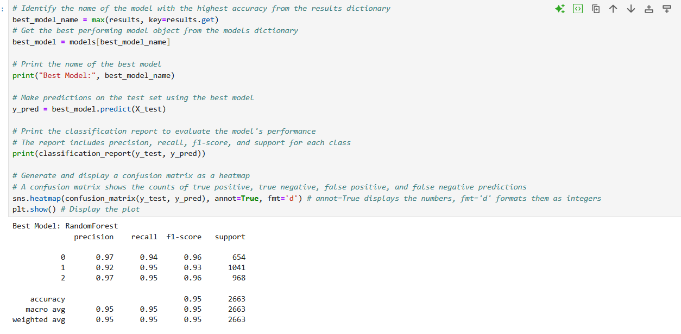
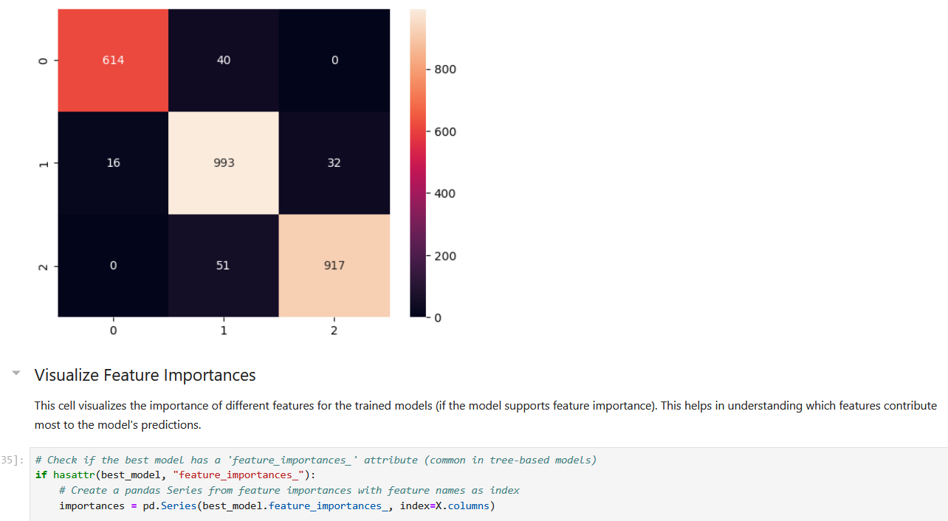
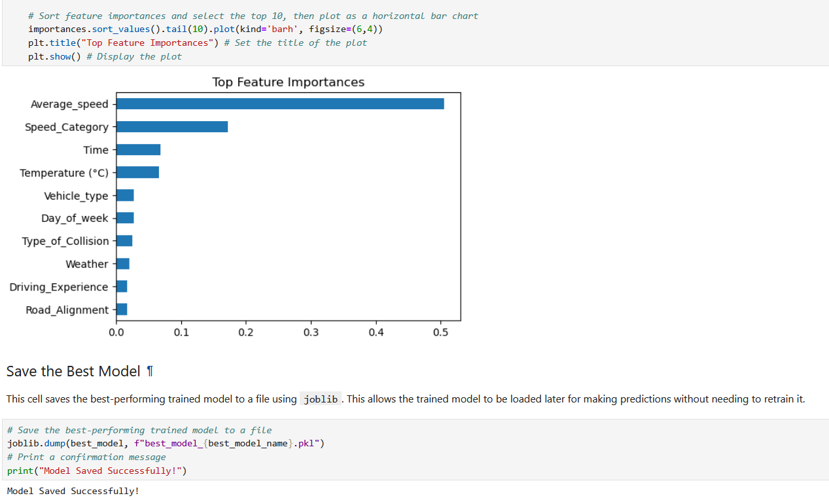
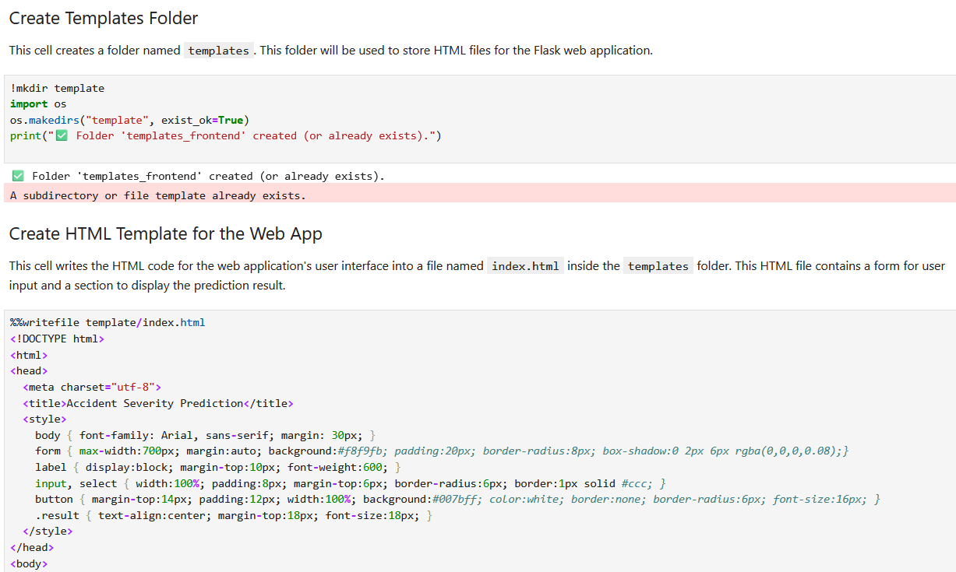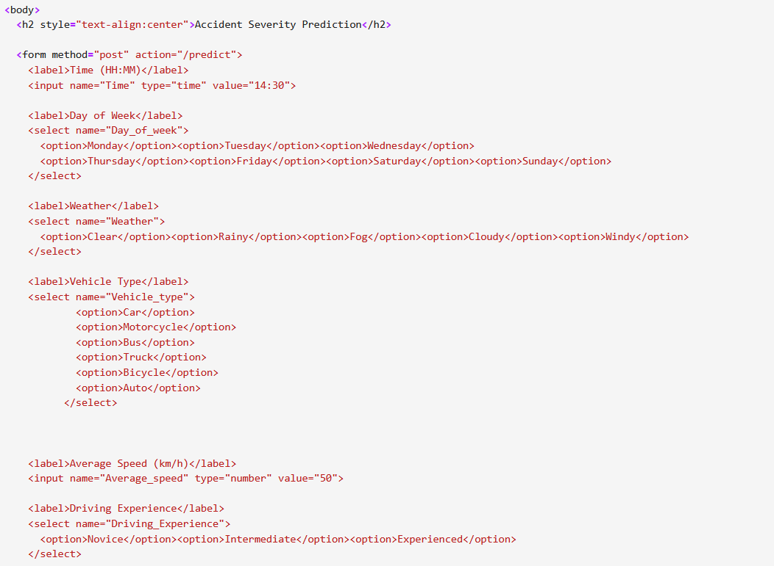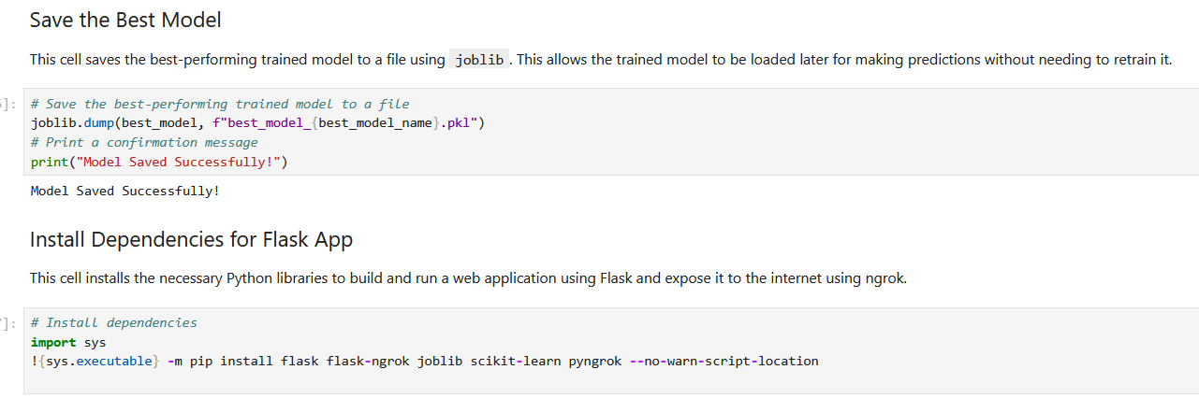
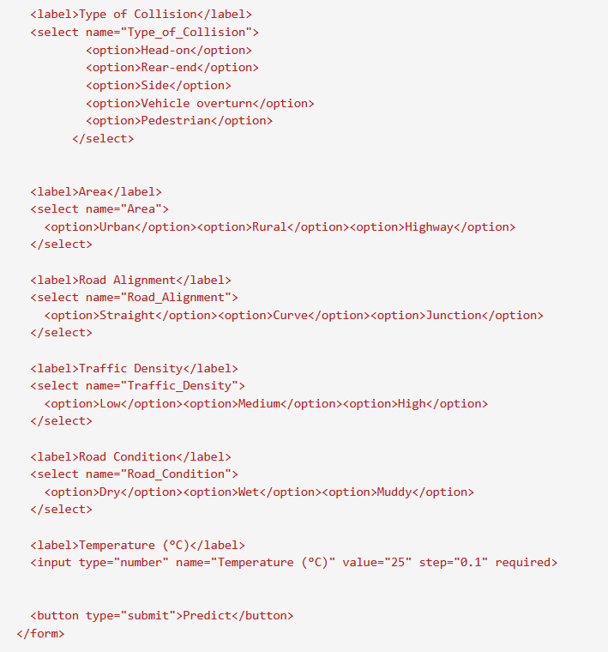

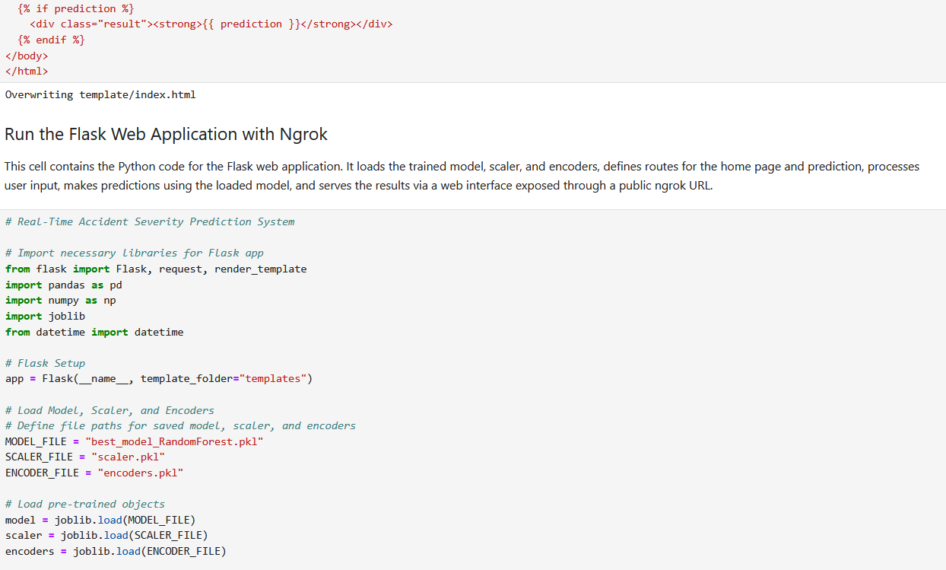
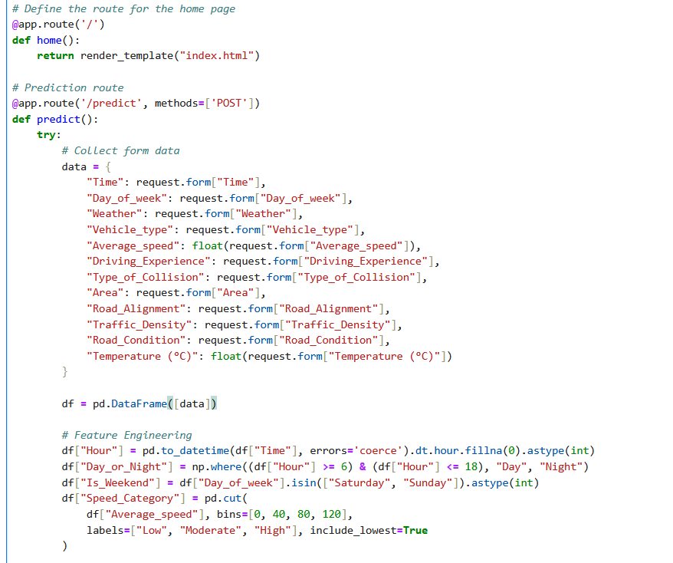
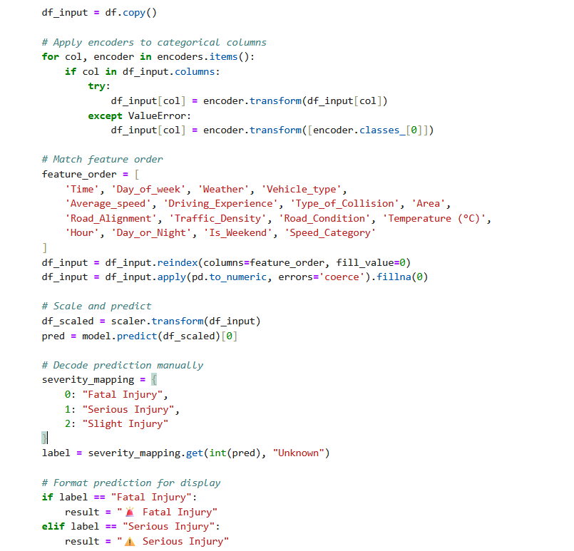

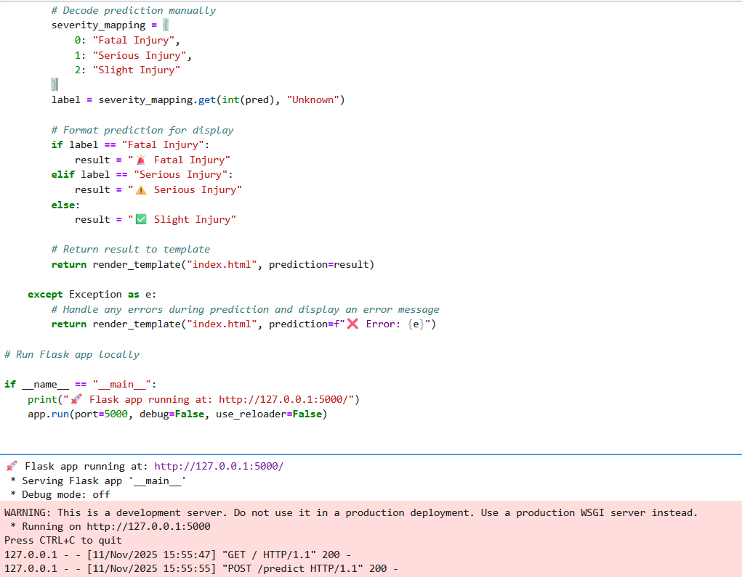
The following are some testcases output screens:
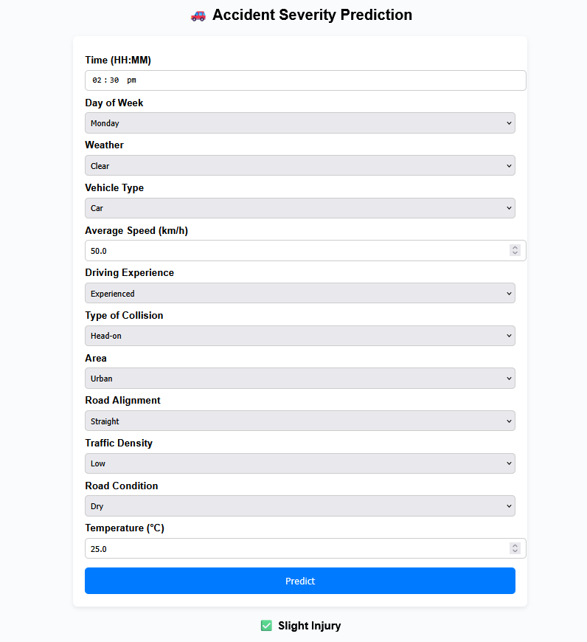
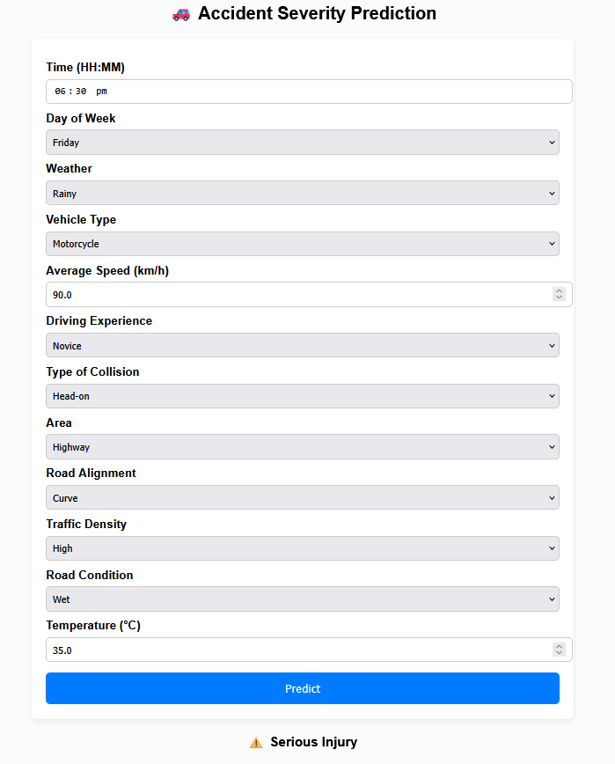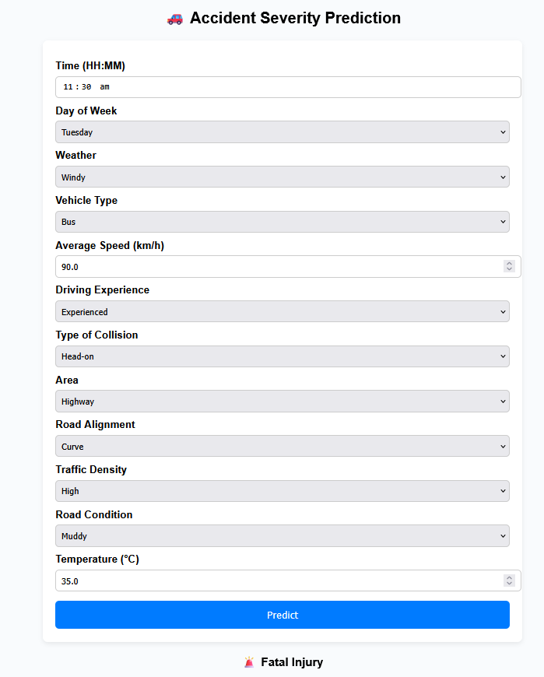

Functional Test Cases for Flask App
Each test simulates form inputs from your HTML and checks how your model responds.
Test Case | Scenario Description | Input Values | Expected Result  or  Output
1 | Clear weather, experienced driver, moderate speed | Time=02:30pm, Day_of_week=Monday, Weather=Clear, Vehicle_type=Car, Average_speed=50, Driving_Experience=Experienced, Type_of_Collision=Rear-end, Area=Urban, Road_Alignment=Straight, Traffic_Density=Medium, Road_Condition=Dry, Temperature (°C)=28 | ✅ Slight Injury
2 | Rainy weather, novice driver, high speed | Time=6:00pm, Day_of_week=Friday, Weather=Rainy, Vehicle_type=Bike, Average_speed=90, Driving_Experience=Novice, Type_of_Collision=Head-on, Area=Highway, Road_Alignment=Curve, Traffic_Density=High, Road_Condition=Wet, Temperature (°C)=24 | ⚠️ Serious Injury
3 | Foggy morning, rural area, low traffic | Time=06:30am, Day_of_week=Sunday, Weather=Fog, Vehicle_type=Truck, Average_speed=45, Driving_Experience=Experienced, Type_of_Collision=Rear-end, Area=Rural, Road_Alignment=Straight, Traffic_Density=Low, Road_Condition=Dry, Temperature (°C)=18 | ✅ Slight Injury
4 | Night, rainy, sharp junction | Time=10:15pm, Day_of_week=Saturday, Weather=Rainy, Vehicle_type=Car, Average_speed=70, Driving_Experience=Intermediate, Type_of_Collision=Side-impact, Area=Urban, Road_Alignment=Junction, Traffic_Density=High, Road_Condition=Wet, Temperature (°C)=22 | ⚠️ Serious Injury
5 | Highway, high-speed, windy weather | Time=11:00am, Day_of_week=Tuesday, Weather=Windy, Vehicle_type=Bus, Average_speed=100, Driving_Experience=Experienced, Type_of_Collision=Head-on, Area=Highway, Road_Alignment=Curve, Traffic_Density=High, Road_Condition=Dry, Temperature (°C)=35 | 🚨 Fatal Injury

Negative Test Cases (Validation & Edge Cases)

Test Case | Scenario | Invalid Input | Expected Behavior
6 | Missing numeric input | Average_speed left empty | Show error message / form validation warning
7 | Invalid temperature input | Temperature (°C) = “abc” | Handle gracefully (show ❌ Error: could not convert string to float)
8 | Unseen category | Weather = “Snowy” (not in training set) | Encoded as default / handled with fallback encoder
9 | Missing field | “Type_of_Collision” not selected | Should not crash; use default or error message
10 | Extreme temperature | Temperature (°C) = 55 | Should still predict a severity class

9.3 Instructions Reference
To reproduce the project:
- Open the notebook and load the dataset.
- Run preprocessing, feature engineering, and model training cells.
- Run the Flask app cell and access the generated link.

Note: Please verify that the related links are correctly placed in the required locations.

9.4 Summary Statement
This project presents a complete end-to-end workflow for a Real-Time Accident Severity Prediction System, encompassing data preprocessing, feature engineering, model training, evaluation, and deployment through a Flask web application. The system effectively demonstrates how machine learning can analyze road accident data to predict severity levels with high accuracy, enabling quicker response decisions and enhancing road safety management. It validates both technical robustness and real-world applicability, highlighting the potential of AI-driven predictive analytics in public safety systems.

THE END

